Project Row for the Planet

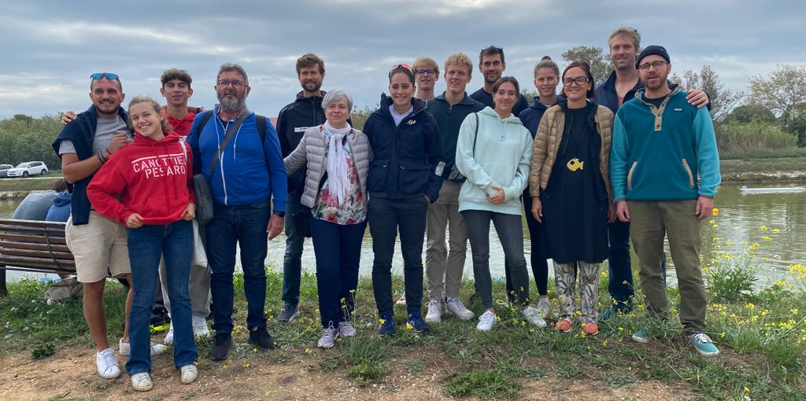

Germany;
Helge Heyken Coach and project coordinator
Kristina Stiefel Project coordinator
Charlotte Hebbelmann Coach and financial manager AAC
David Backhaus U17 rower
Hugo Thomas U16 rower

France ;
Gael DEPIERRE Project coordinator
Christian MODOLA Project coordinator
Joana ROCHA Coach and project coordinator
Daniela RAINOLDI
Marlon DEPIERRE Physical education teacher and coach
Thomas KOVACS Language facilitator
Cassandra MARCHAND U20 rower
Edward FISHER U16 rower

Italy ;
Fabio Patrignani Coach and project coordinator
Eugenio Balducci Coach
Davide Treggiari U18 rower
Elena Cospito U16 rower
The project

Row For The Planet is a project led by the SUD Provence Alpes Côte d'Azur league and the AAC Alster club union and a group of Italian clubs Fano. The project will end with a 10-day course in Montauroux (from 10 to 20 July). The objective of this one will be to be in a completely eco-responsible approach. This one thus directs us on an operation of free management:
⁃ Food shopping in short circuit
⁃ Food shopping in bulk
⁃ Travelling by foot, bicycle or public transport

This project will involve 50 young people from the three countries, aged between 15 and 23. We chose this age group for two reasons:

- This is the time when young teenagers can really build a thoughtful approach to reducing the impact of our consumer society on Earth.
- It is also an age when we see a strong decrease in the number of members in our structures, and we want to give them another reason to remain members.

During the course each action will have a carbon footprint, and we will calculate it every day to realise our impact on the Planet. One goal; to reduce your carbon footprint every day during the course. The awareness will have the effect of post-course communication and a questioning of each participant, direct or not, to the course.
To make this course fun, the activities will be varied and of course as green as possible. Between rowing, cycling, hiking, orienteering, sports games and many other activities ... The program of the course remains intense, because we will be in free management, group rotations will be done for shopping, meals.

We will all be accommodated in a campsite close to the water sports base, thus facilitating our movements.
The activities will all be possible without too much travel time.
At the middle of the course, an evening presentation of our project and its approach will be made at the campsite, so that all holidaymakers who wish to do so can benefit. An Italian lecturer will also come to make an intervention to raise awareness and observe the work done by the team and the young people.

Summary of the Kick-off meeting 1

It took place in Marseille on 08 and 09 October 2022

Vendredi 7 octobre | Samedi 8 octobre | Dimanche 9 octobre
 | 8am-12pm - Marseille Rowing Club  Reminder of the elements of the Grant Agreement  Reminder of deliverables and publication dates | 9am-12pm - Club Marignanais Aviron  Group work on the Social Networks to be implemented  Group work on the Guideline
 | 12:00-13:00 Lunch at l'Estaque
Lunch together  Settling in at the Hotel Ibis Estaque 1.30-5pm | Presentation of the Local Green Actions  Group work on the programme  6pm-11pm  Visit of Marseille

This meeting, work package 1, is part of the project and is funded by Erasmus+.

This first inter-country meeting allowed us to bring a reflection on the project and its content. On our first day, the main task was to make sure that the objectives expected by Erasmus in the Grant Agreement charter were well understood. We discussed the action points for the work package deliverables.
Each party involved in the project presented itself to the whole group.
Afterwards, each party also presented the action steps that were going to be put in place to make the case.
Each country has a well-defined action plan. These actions will reach a different public than the one that will be mobilised by the course. These territorial actions will allow us to reach many more people than the 50 young people who will be on the final course.

The actions will be presented later on this website and on our social networks.
A group work was carried out by the 6 young people present from the three countries; they were asked to think about the modes of transport to go to Montauroux this summer while being the most ecologically responsible.
The programme of the course has been largely predefined, now we have to implement the research of actors who will be part of our project through their provision of activities.

All our articles will be available in French, German, Italian and English.

Row for the planet
@rowfortheplanet
@rowfortheplanet

